**M A N U A L**

**OutC4se**

**U Sungkyung**

**Choi Jinyoung**

**Jang Hyejun**

**Son Jinhyuk**

**2014. 12. 14.**

목차

1 Windows 2

1.1 Install 2

1.1.1 Autopsy 2

1.1.2 Python 5

1.1.3 Python Module 6

1.1.4 Set Environment Variable 12

1.1.5 Plug-in Module 15

1.2 Operation 21

1.2.1 Train the Model 21

1.2.2 Classfy 25

1. Windows
   1. Install
      1. Autopsy

- Download Version 3.1.1

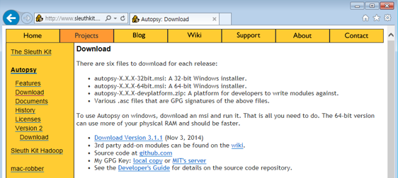

<http://www.sleuthkit.org/autopsy/download.php>

-Install

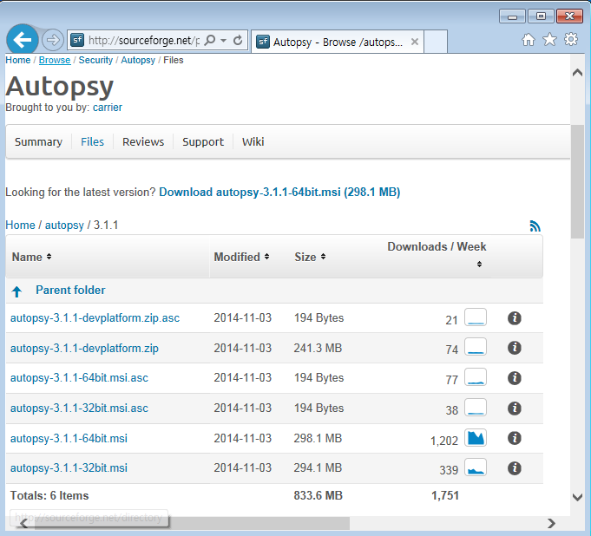

<http://sourceforge.net/projects/autopsy/files/autopsy/3.1.1/>

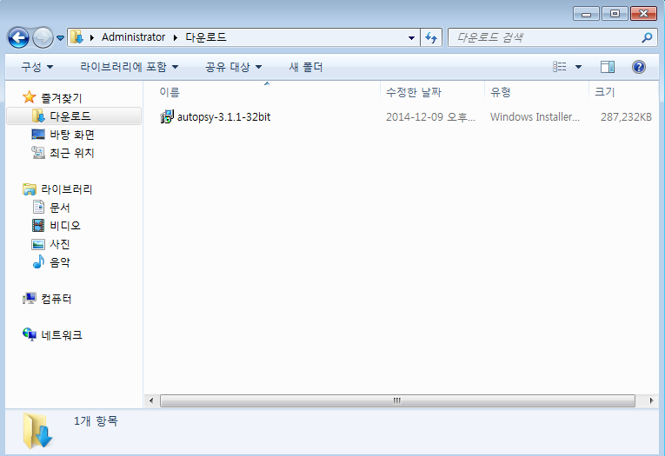

Next -> Next -> Install -> Finish

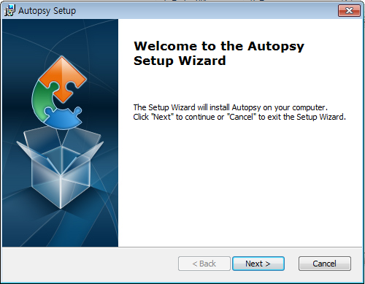

* + 1. Python

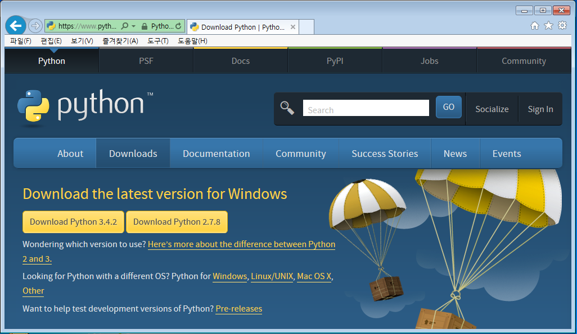

<https://www.python.org/downloads/>

Next → Next → Finish

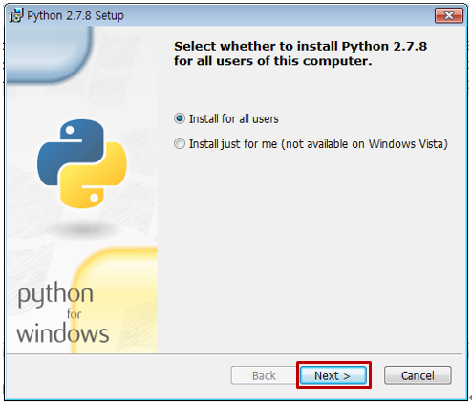

* + 1. Python Module

We made a program by Python, so you have to install some Python modules. You can download those files at the site below, and find the modules you want by Ctrl + F.

<http://www.lfd.uci.edu/~gohlke/pythonlibs/>

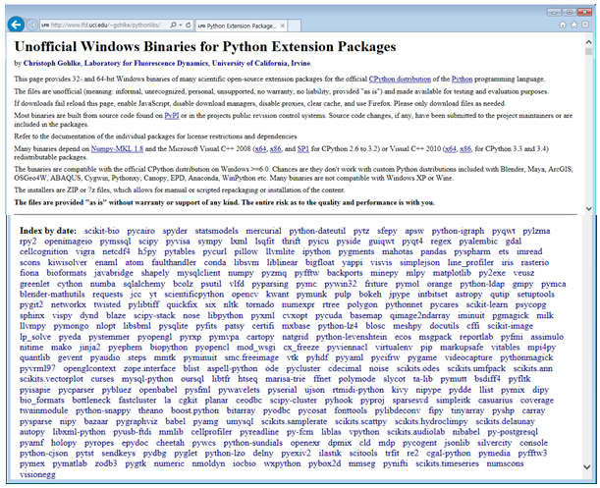

Modules that you have to install.

|  |
| --- |
| pillow / numpy / scipy / scikit-learn / matplotlib / six / python-dateutil / pyparsing |

<http://www.lfd.uci.edu/~gohlke/pythonlibs/#pillow>

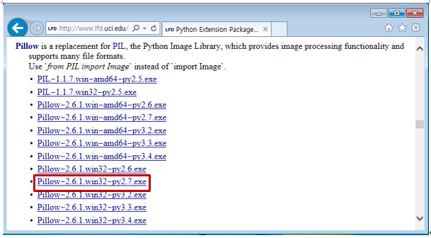

Next -> Next -> Next -> Finish

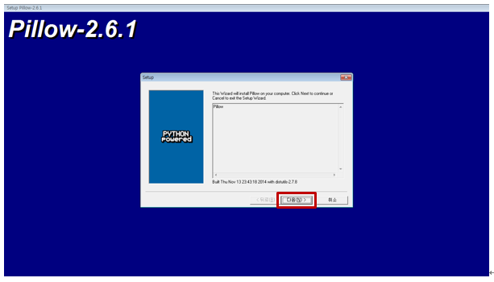

<http://www.lfd.uci.edu/~gohlke/pythonlibs/#numpy>

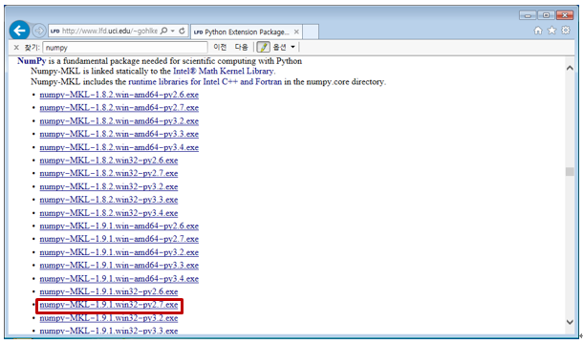

Next steps of installation is similar with first module

[http://www.lfd.uci.edu/~gohlke/pythonlibs/#scipy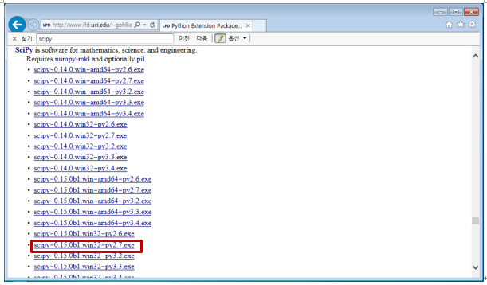](http://www.lfd.uci.edu/~gohlke/pythonlibs/#scipy)

<http://www.lfd.uci.edu/~gohlke/pythonlibs/#scikit-learn>

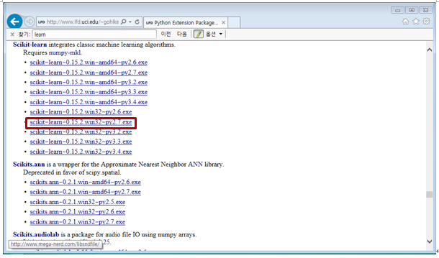

<http://www.lfd.uci.edu/~gohlke/pythonlibs/#matplotlib>

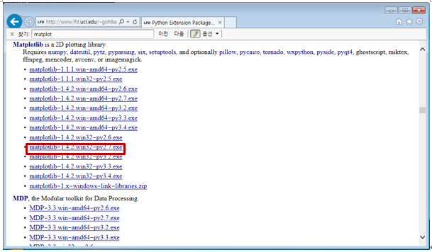

[http://www.lfd.uci.edu/~gohlke/pythonlibs/#six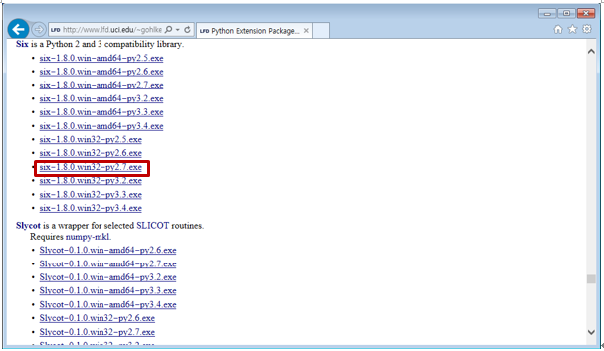](http://www.lfd.uci.edu/~gohlke/pythonlibs/#six)

<http://www.lfd.uci.edu/~gohlke/pythonlibs/#python-dateutil>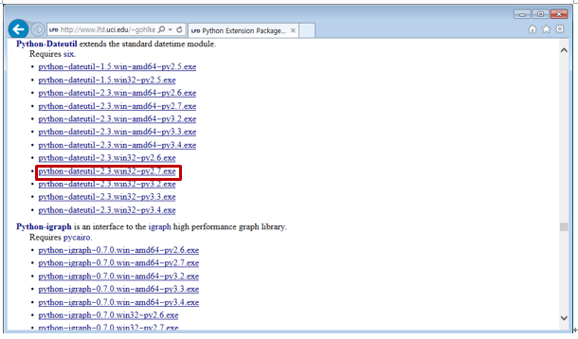

[http://www.lfd.uci.edu/~gohlke/pythonlibs/#pyparsing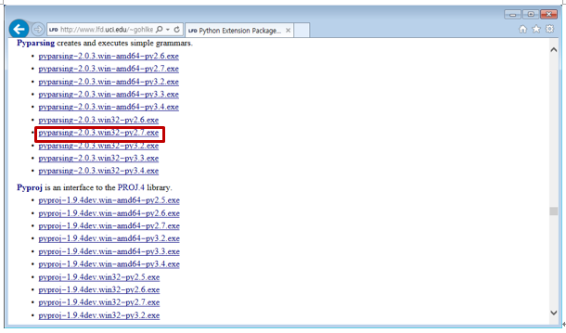](http://www.lfd.uci.edu/~gohlke/pythonlibs/#pyparsing)

* + 1. Set Environment Variable

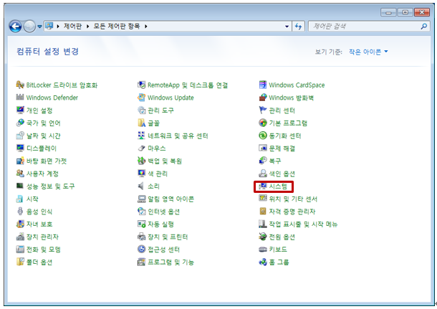

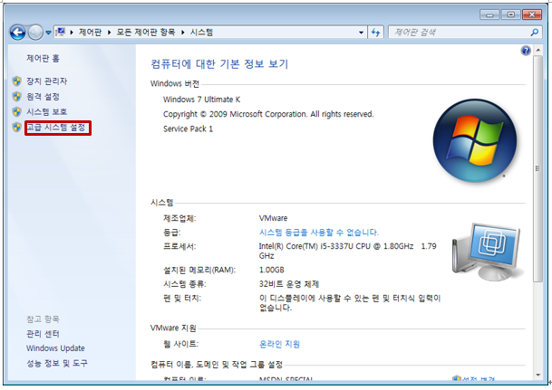

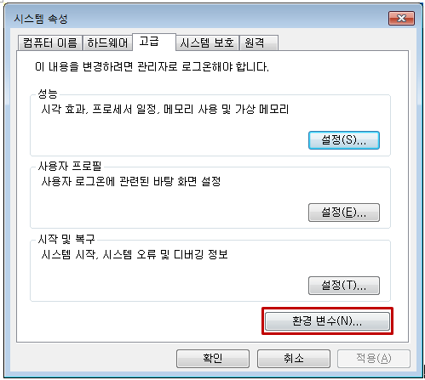

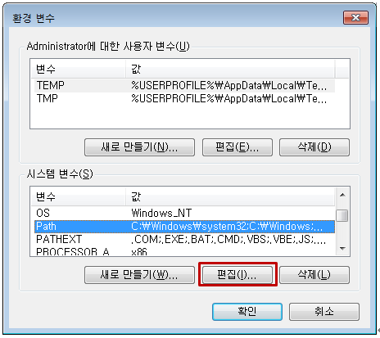

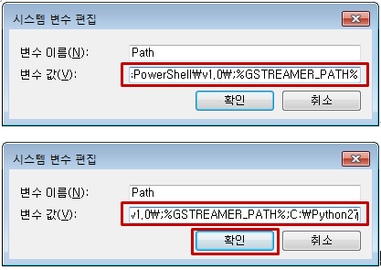

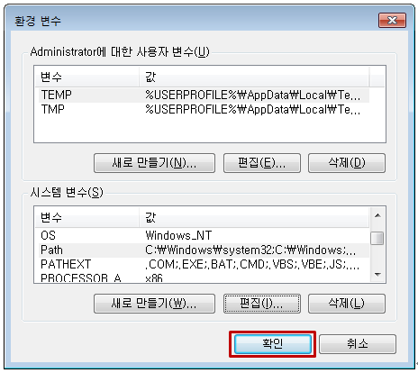

* + 1. Plug-in Module

<https://github.com/hvva/autopsy-CV>

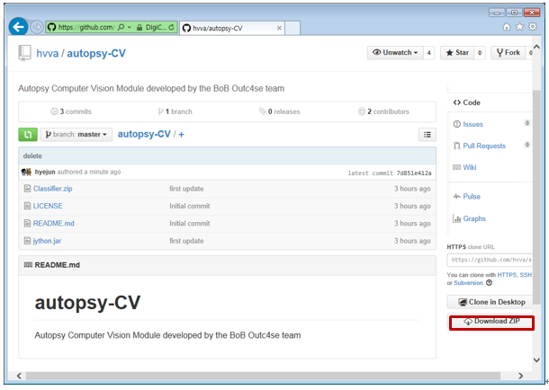

In autopsy-CV folder, move to Classifier – Source and copy the Vlfeat folder.

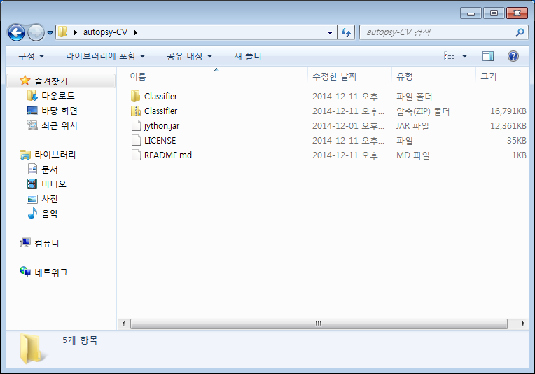

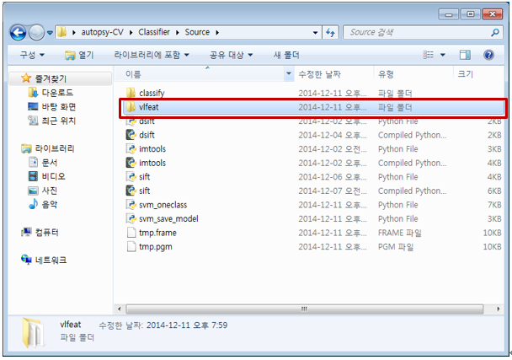

And Paste to Program Files – Autopsy-3.1.1 folder.

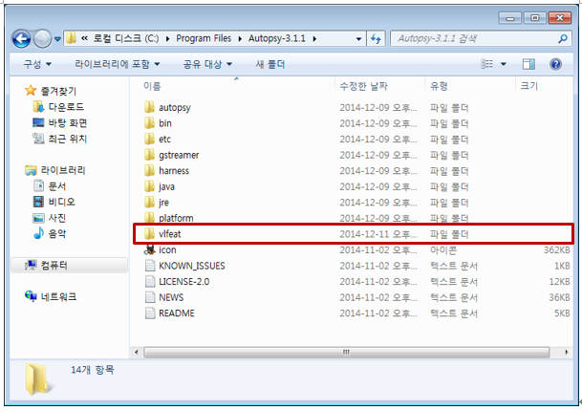

In autopsy-CV folder, copy the jython.jar ,

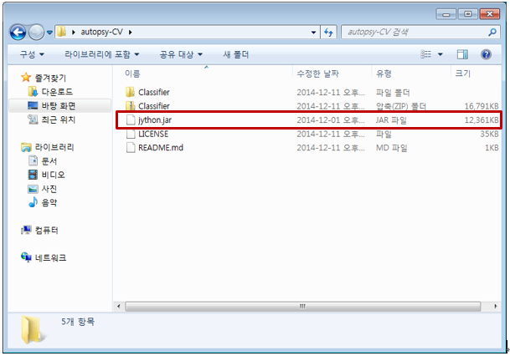

Paste it to Program Files – Autopsy-3.1.1 – autopsy – modules – ext folder.

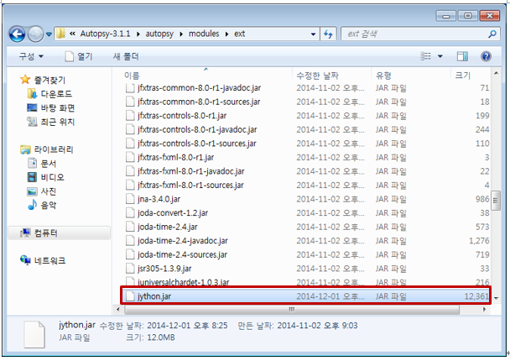

Finally, in autopsy-CV folder, copy the Classifier folder,

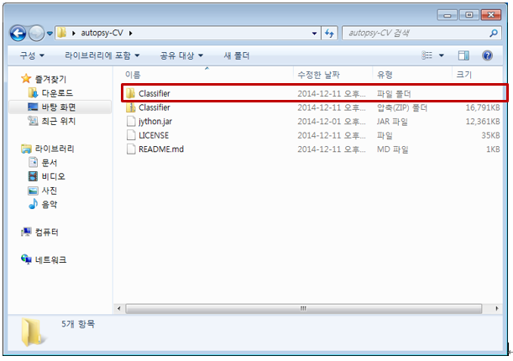

Paste it to

Local Disk(C:) – 사용자 – (사용자이름) – AppData – Roaming – autopsy – python_modules

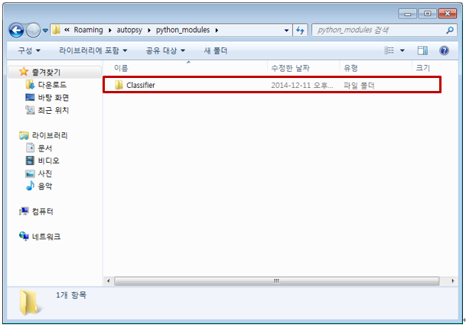

* 1. Operation
     1. Train the Model

Put the train images to Classifier - Source – classify – Train folder.

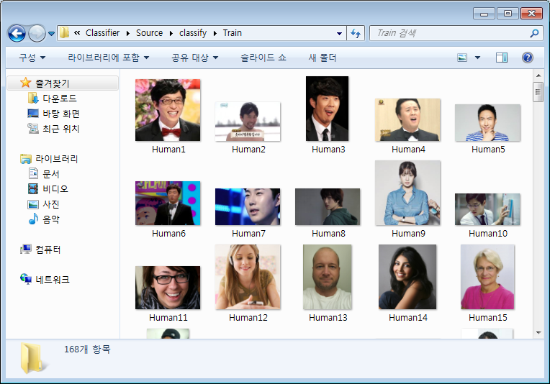

Start the svm_save_model.py by IDLE in Classifier – Source folder.

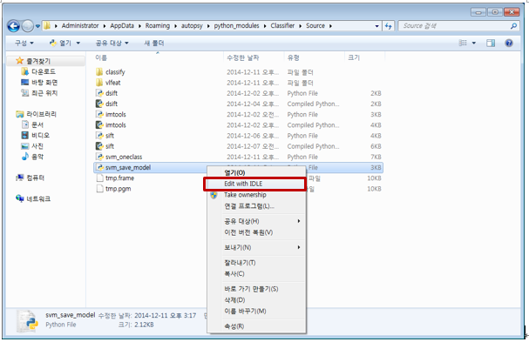

Write the model’s name you want to make in Save_model variable.

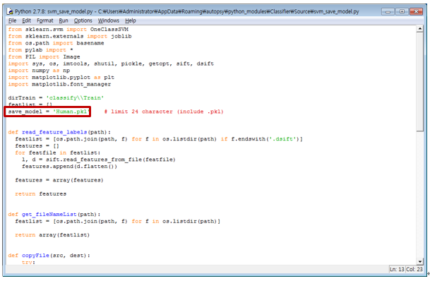

Run – Run Module (F5)

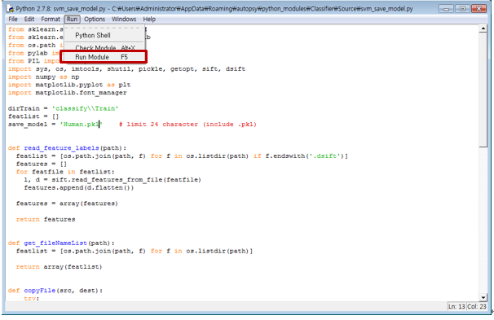

Make the dsift files of the images in Train folder, and train the model by those dsift files.

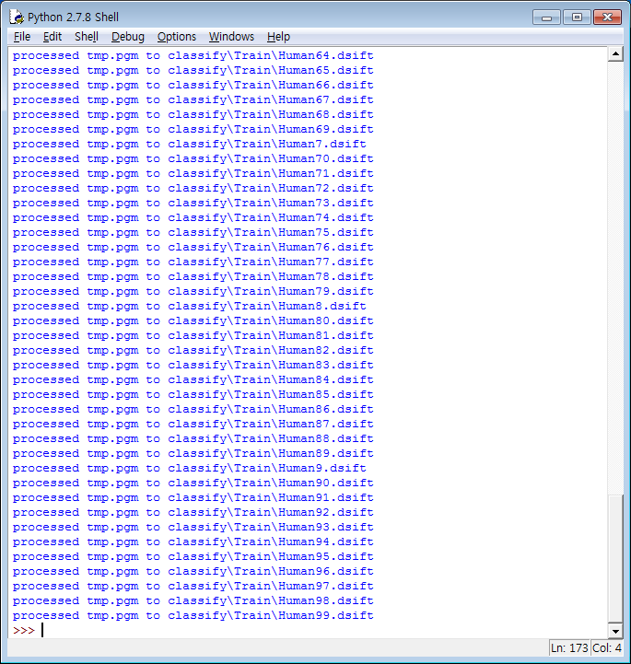

After the running svm_save_model.py is finished, you can check that the Human.pkl is generated in Source folder.

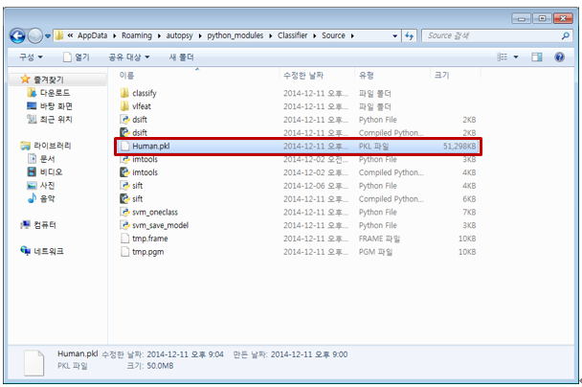

Move the Human.pkl to Local Disk(C:) – Program Files – Autopsy-3.1.1 .

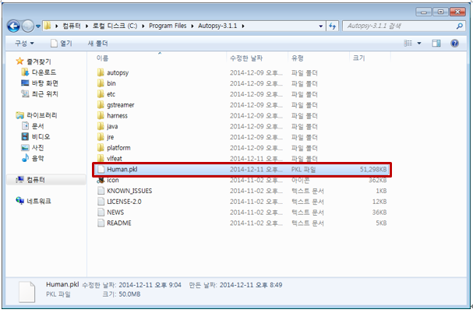

* + 1. Classfy

Run the Autopsy.

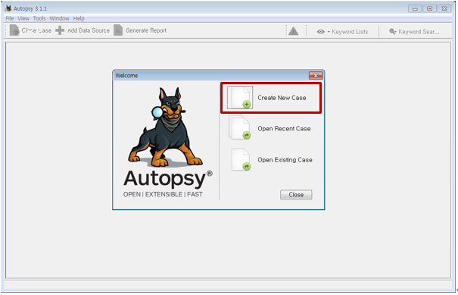

Write the Case Name.

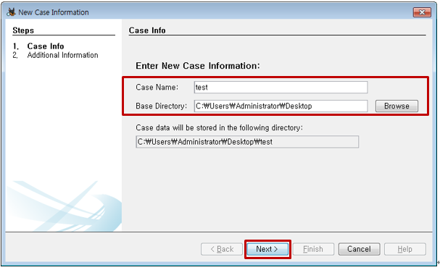

Write the Case Number and Examiner.

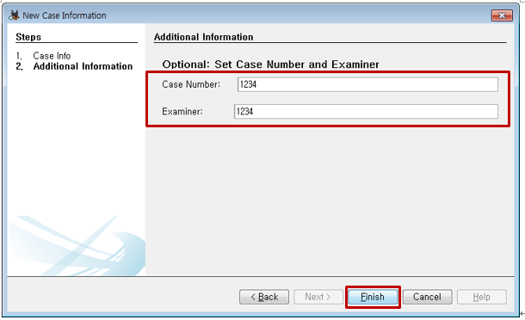

Select the Source type .

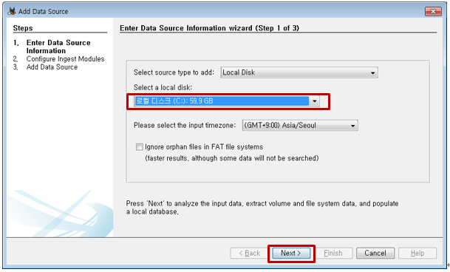

Next - Finish

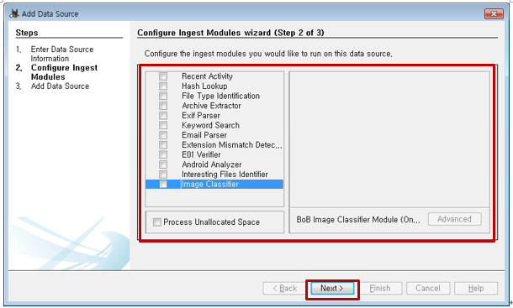

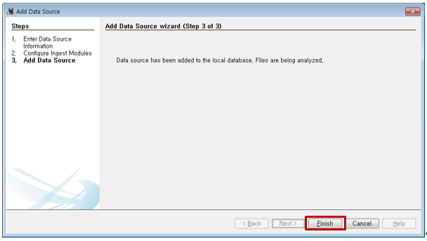

Right-click (C:) and select Run Ingest Module.

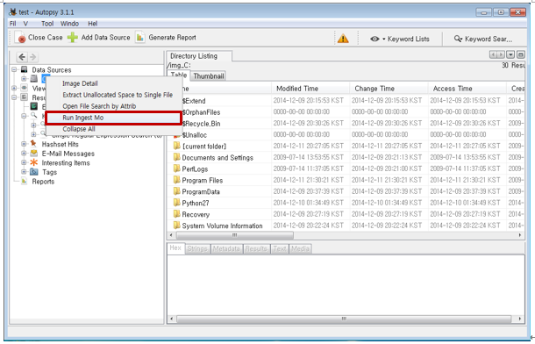

Check Image Classifier.

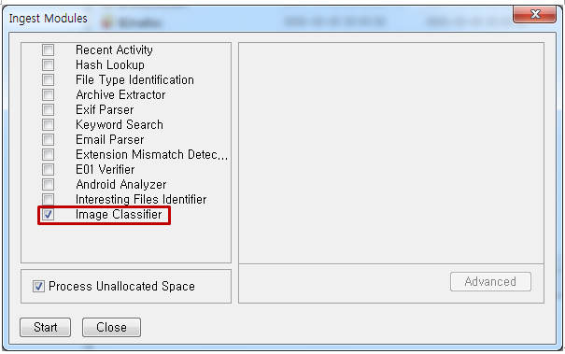

When Cmd windows opened, write the model name that you want to classify.

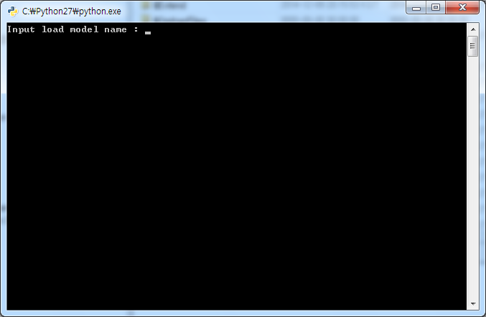

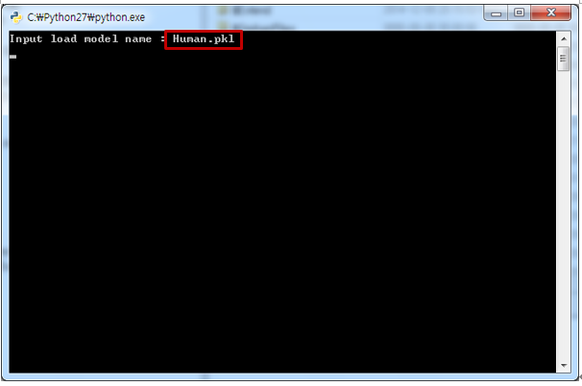

After running is finished, the number of files that classified as Human prints by ‘Valid’,

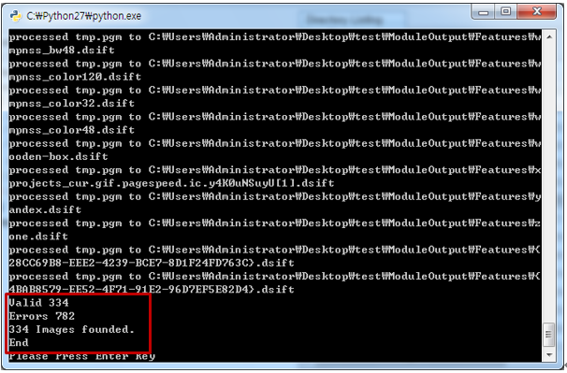

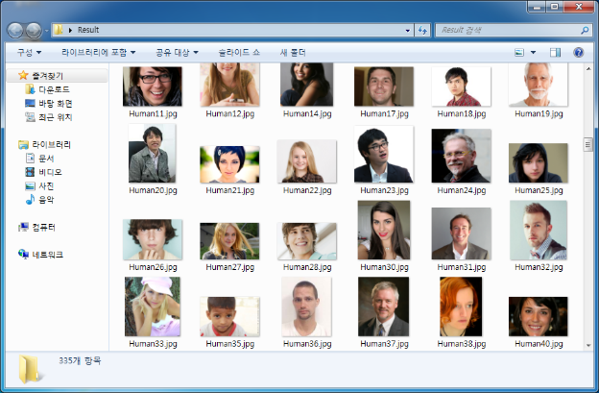Images which is classified as Human is saved in Result folder on the Desktop.

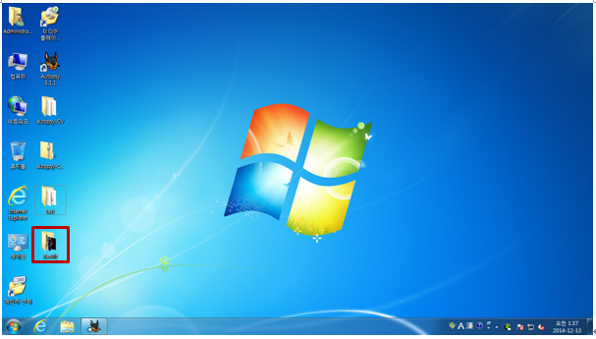You can check the result by Report.txt.

